**Department of Information Technology**

**Academic Year: 2022-23 Name of Student:**

**Semester: V Student ID:**

**Class / Branch/ Div: TE- IT A/B Roll No.**

**Subject: IP Lab Date of Submission:**

**Name of Instructor: YP/RS/SA**

**Experiment No.:4**

**Aim:** Write a program to enhance styling of your webpage using Bootstrap.

**Software Used:** Visual Studio Code

**Theory:**

What is Bootstrap?

Bootstrap is a free front-end framework for faster and easier web development.Bootstrap is the most popular HTML, CSS, and JavaScript framework for developing responsive, mobile-first websites.

**main.html**

<!DOCTYPE html>

<head>

<linkrel="stylesheet" href="https://cdn.jsdelivr.net/npm/bootstrap@4.6.1/dist/css/bootstrap.min.css">

</link>

</head>

<body style="background-color: yellowgreen;">

<!-- <h1><b> SHITAL AGRAWAL</b></h1> -->

<div style="color:#1e6dce; padding: 1rem 1rem; background-color: inherit;" class="jumbotron jumbotron-fluid">

<div style="margin-left: 0;" class="container">

<h1>SHITAL AGRAWAL

<img src="lotus-flower.jpg" alt="student dp" width="40" style="margin-bottom: 10px;">

</h1>

</div>

</div>

</h1>

<div style="font-size:40px;color:blue;">

<ul class="nav justify-content-center">

<li class="nav-item">

<a class="nav-link active" href="Basic.html">Basic</a>

</li>

<li class="nav-item">

<a class="nav-link" href="Academic.html">Academic</a>

</li>

<li class="nav-item">

<a class="nav-link" href="other.html">Other</a>

</li>

</ul>

</div>

<footer style="text-align: center; bottom: 0; width: 100%; position: fixed; color: #9ea9af;">

<p> A.P.SHAH INSTITUTE OF TECHNOLOGY </p>

</footer>

</body>

</html>



**Basic.html**

Basic.html

<!DOCTYPE html>

<html lang="en">

<head>

<title>Student Portfolio </title>

<linkrel="stylesheet" href="https://cdn.jsdelivr.net/npm/bootstrap@4.6.1/dist/css/bootstrap.min.css">

</head>

<body style="background-color: #eff3f6;">

<!-- <header>

<h1> My Portfolio</h1>

</header> -->

<div style="color:#1e6dce; padding: 1rem 1rem; background-color: inherit;" class="jumbotron jumbotron-fluid">

<div style="margin-left: 0;" class="container">

<h1> My Portfolio</h1><br>

<button class="btn btn-danger"><a href="main.html">home </a></button>

</div>

</div>

<!-- </section>

<section> -->

<div class="container">

<h2 style="color: rgb(75, 75, 75);" class="card-title">Basic Information</h2>

<div class="row" style="border: 1px solid rgb(201, 201, 201); padding: 30px; border-radius: 5px;">

<div class="col-md-6">

<div class="card" style="width: 18rem;">

<div style="padding: 30px;">

<!-- <div class="bg-image hover-zoom"> -->

<img src="lotus-flower.jpg" alt="student dp" class="w-100" />

</div>

<!-- </div> -->

<div class="card-body">

<h5 class="card-title">Shital Agrawal</h5>

<p class="card-text">

Class: TE

</br>

Department: IT

</p>

</div>

<div class="card-footer text-muted">

<ahref="https://mail.google.com/mail/u/0/#inbox">syagrawal2801@gmail.com</a>

</div>

</div>

</div>

<div class="col-md-6">

<div class="container">

<h5 class="card-title">MY HOBBIES</h5>

<ul class="list-group">

<li class="list-group-item">Reading</li>

<li class="list-group-item">Playing</li>

<li class="list-group-item">Dancing</li>

</ul>

</div>

</div>

</div>

</div>

<footer style="text-align: center; bottom: 0; width: 100%; position: fixed; color: #9ea9af;">

<p> A.P.SHAH INSTITUTE OF TECHNOLOGY </p>

</footer>

</body>

</html>

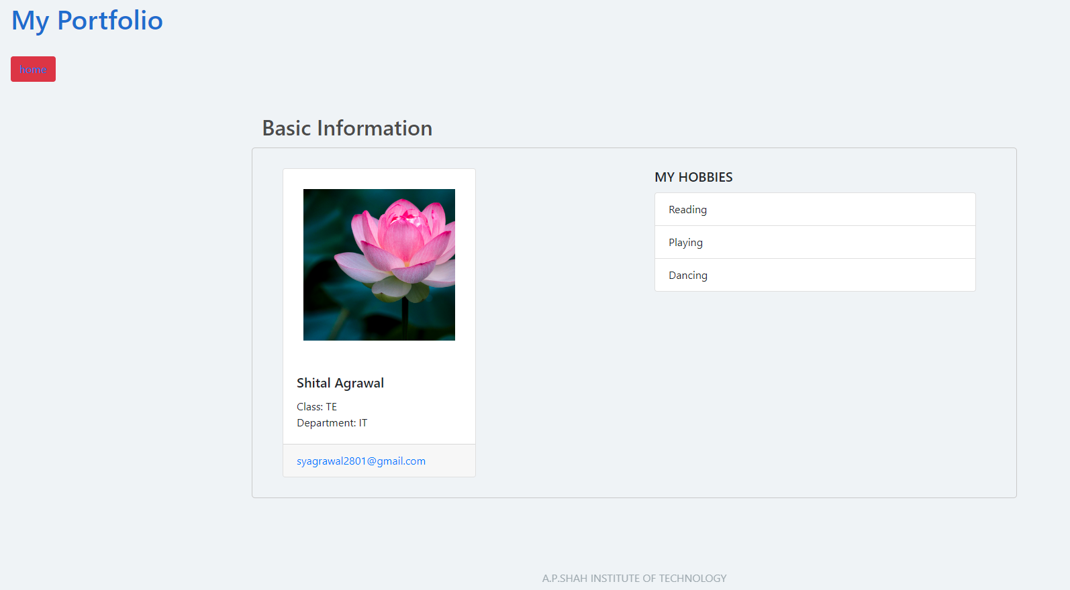

Academic.html

<!DOCTYPE html>

<html lang="en">

<head>

<style>

.p1{

text-align: center;

font-family: Lucida Handwriting;

font-size: 50px;

}

</style>

<meta charset="UTF-8">

<meta http-equiv="X-UA-Compatible" content="IE=edge">

<meta name="viewport" content="width=device-width, initial-scale=1.0">

<title>Academic Details</title>

<link rel="stylesheet" href="https://cdn.jsdelivr.net/npm/bootstrap@4.6.1/dist/css/bootstrap.min.css">

</link>

</head>

<body style="background-color: yellow;">

<div style="color:#1e6dce; padding: 1rem 1rem; background-color: inherit;" class="jumbotron jumbotron-fluid">

<div style="margin-left: 0;" class="container">

<h1>Academic Achievements</h1>

<br>

<button class="btn btn-danger"><a href="main.html">home </a></button>

</div>

</div>

<div class="container">

<table class="table table-bordered ">

<thead class="thead-light">

<tr>

<th>EDUCATION LEVEL</th>

<th>INSTITUTE</th>

<th>YEAR</th>

<th>MARKS</th>

</tr>

</thead>

<tr>

<td>SSC</td>

<td>SINGHANIA SCHOOL</td>

<td>2014</td>

<td>70%</td>

</tr>

<tr>

<td>HSC</td>

<td>A.P. SHAH ENGINEERING COLLEGE</td>

<td>2016</td>

<td>60%</td>

</tr>

<tr>

<td>Diploma</td>

<td>WADIA</td>

<td>2018</td>

<td>63%</td>

</tr>

<tr>

<td>BE</td>

<td>JSCOE</td>

<td>2020</td>

<td>72%</td>

</tr>

</table>

</div>

<br>

<br>

<br>

<div class="jumbotron jumbotron-fluid">

<p class="p1"> Above Marks Have Been Verified</p>

</div>

<footer style="text-align: center; bottom: 0; width: 100%; position: fixed; color: #9ea9af;">

<p> A.P.SHAH INSTITUTE OF TECHNOLOGY </p>

</footer>

</body>

</html>

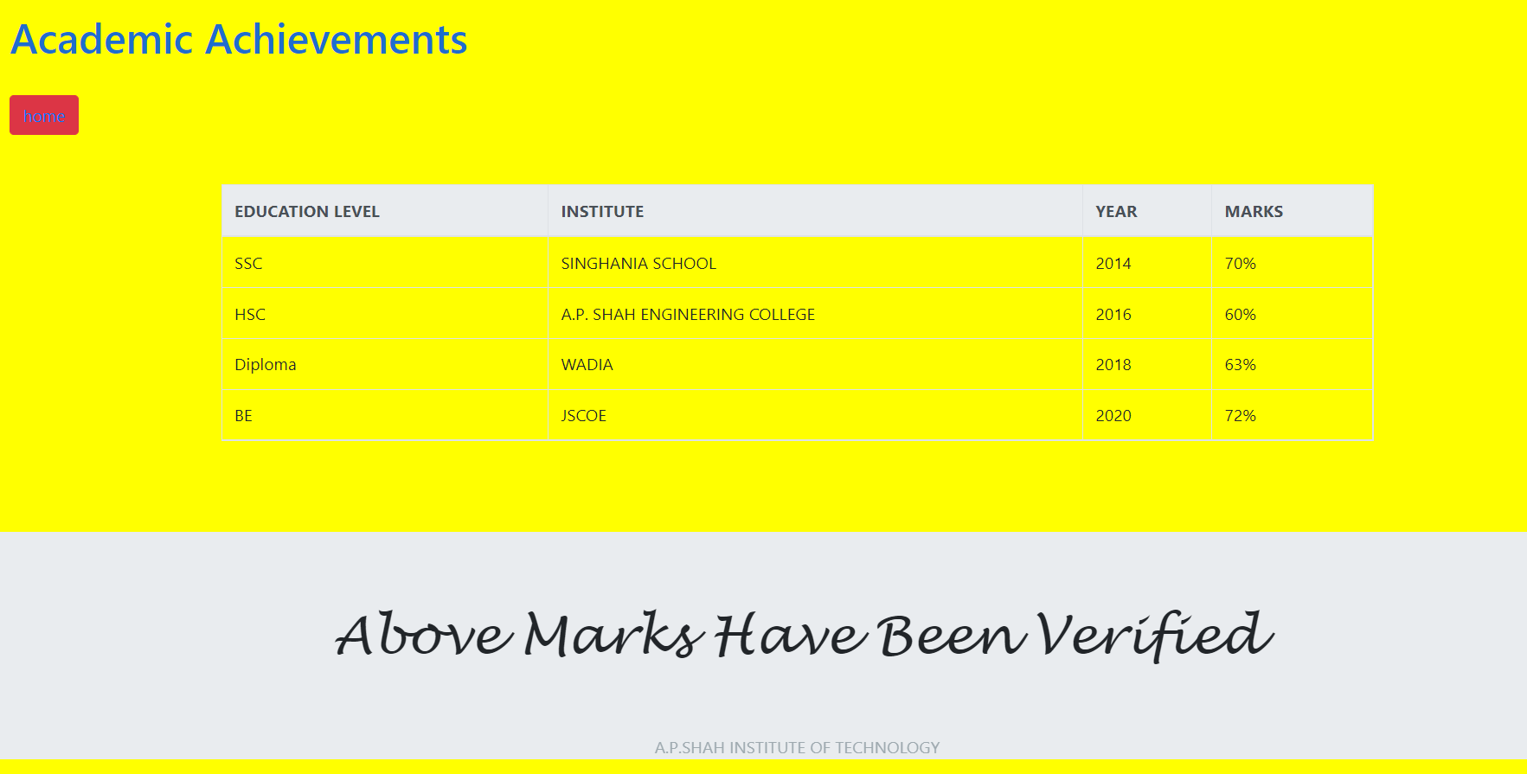

**Other.html**

<!DOCTYPE html>

<html lang="en">

<head>

<meta charset="UTF-8">

<meta http-equiv="X-UA-Compatible" content="IE=edge">

<meta name="viewport" content="width=device-width, initial-scale=1.0">

<title>Other Info</title>

<link rel="stylesheet" href="https://cdn.jsdelivr.net/npm/bootstrap@4.6.1/dist/css/bootstrap.min.css">

</head>

<body style="background-color:pink;">

<div style="color:#1e6dce; padding: 1rem 1rem; background-color: inherit;" class="jumbotron jumbotron-fluid">

<div style="margin-left: 0;" class="container">

<h1>OTHER COURSES</h1>

<br>

<button class="btn btn-danger"><a href="main.html">home </a></button>

</div>

</div>

<div class="container">

<ul class="list-group">

<li class="list-group-item">PYTHON ESSENTIAL</li>

<li class="list-group-item">LINUX ESSENTIAL</li>

<li class="list-group-item">NETWORKING ESSENTIAL</li>

</ul>

</div>

<div class="container">

<br>

<form >

<label>COMMENT</label>

<textarea row="5" cols="10" class="form-control"></textarea>

</form>

</div>

<footer style="text-align: center; bottom: 0; width: 100%; position: fixed; color: #9ea9af;">

<p> A.P.SHAH INSTITUTE OF TECHNOLOGY </p>

</footer>

</body>

</html>

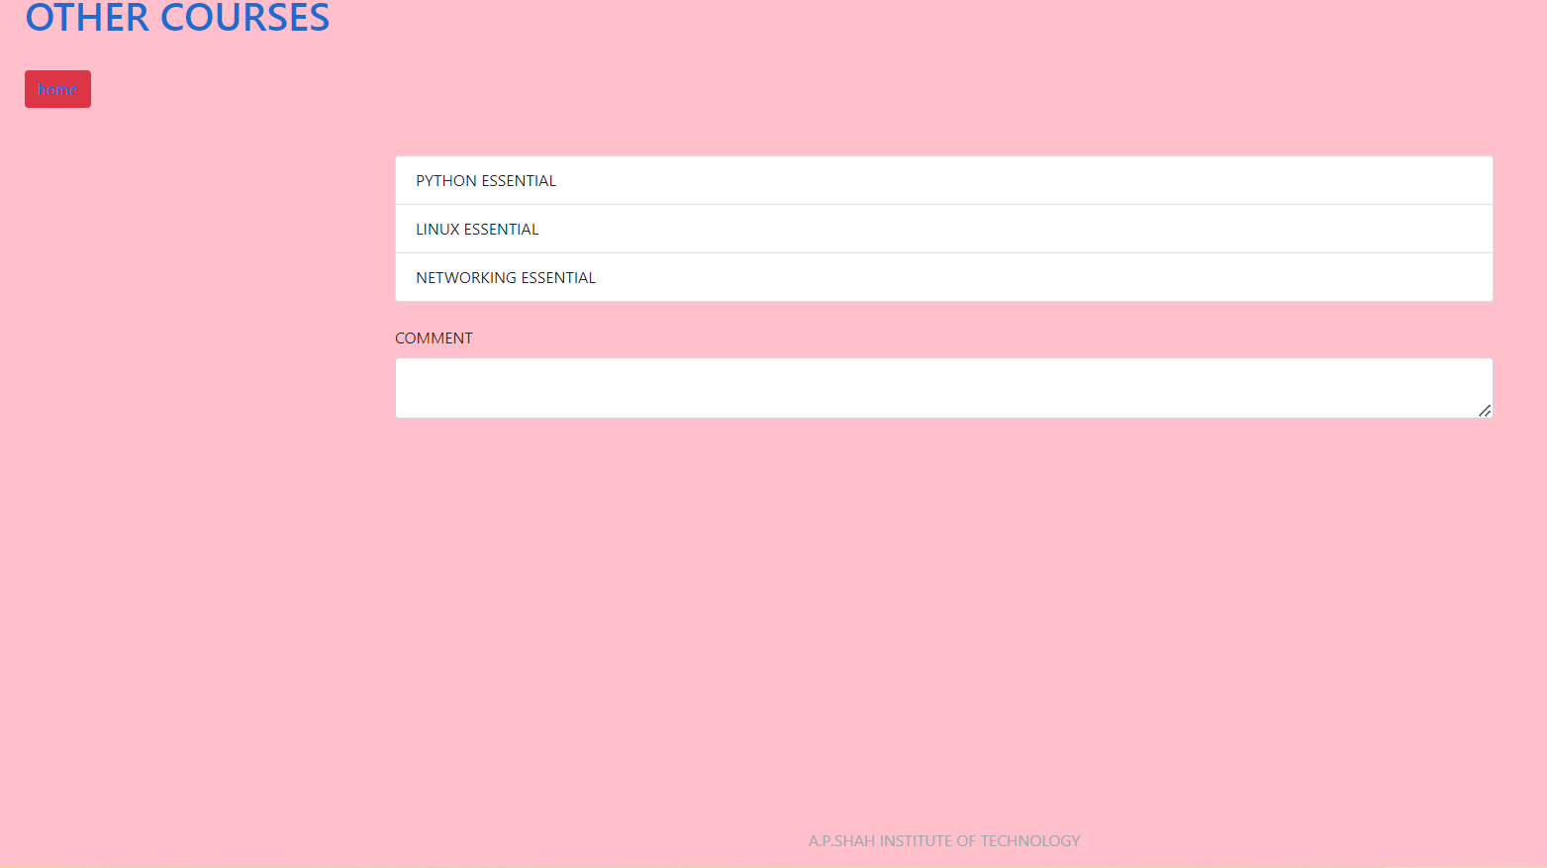

**Conclusion:** Thus, We have implemented a program to enhance styling of webpage using Bootstrap.